Leapfrog Nursery School – Compton Road
Booking Form 2024

Full Name of child________________________________ DOB _____________________________

Name of parent__________________________ Email __________________________________

Address ______________________________________Postcode __________________________

Start date ________________ Mobile ____________________________

How did you hear about Leapfrog Nursery ______________________________________

- Tick box to confirm the fee structure has been explained to you – information on reverse.

Signature of parent____________________________ Date ______________________

Minimum of 2 days required. We recommend you take up the maximum number of sessions, as you may not be able to increase sessions during the year.

(8.30/9.00am-3.00/4.00pm) please circle start & finish time.
Monday Tuesday Wednesday Thursday Friday

8.30/9.00 – 12.00, or 8.30/9-3/4 Toddler room Please specify finish time
Monday Tuesday Wednesday Thursday Friday

(NB While we do our best to accommodate your choices we cannot always guarantee to do so.)

Please return this form ASAP with a deposit/Waiting list fee of £100. If we do not hear from you we will assume you no longer require a place at Leapfrog.

If Applicable, Terrific Twos funding Code: ________________________________
If Applicable, 2 year old 15 hour code, or 3 year old 30 Hours Eligibility Code: __________________________________

Please either send the form to Leapfrog Nursery School, 29 The Green, N21 1HS or you can email a photo of the form if it is easier. Our bank details for the deposit are:
Sort Code: 20-29-77 Account no: 10420611, please use your child’s name as the reference.

email: stayandplayleapfrog@gmail.com or website: www.leapfrognurseryschool.co.uk

Official Use Only: Deposit__________________________

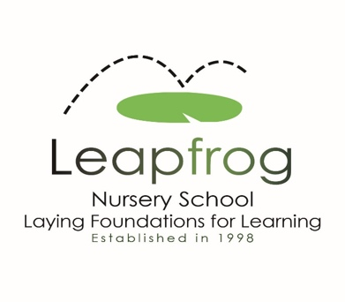

Leapfrog Nursery School Fees

We are completely transparent with our fee structure, using an hourly rate to keep things simple.

Our hourly rate from September 2023 is £10.50.

15 hours a week of Government funding is available the term after your child is 3 for all families. The nursery claims the funding on your behalf, and you will not need to apply for this.
The funding amount from April 2024 is £6.03 per hour. We invoice parents for the remainder, which stands at £4.47per hour from 15 up to 30 hours per week, dependant on eligibility.

!! Government funding is also now available for eligible families from the term after your child is 2. !!
You will need to provide the nursery with your eligibility code to enable us to claim this.
The funded amount from April 2024 IS £9.10 per hour. We invoice parents for the remaining amount which stands at £1.47 per hour for up to 15 hours a week.

We invoice parents termly but can accept monthly payments if you prefer.
The deposit/fee to secure your place is £100, £40 of which is deducted from the first invoice you receive, however if you pay the deposit/waiting list fee and then decide you no longer want the nursery place, the deposit is non – refundable.

You may be eligible for tax free childcare, (20% off your fees) and up to 30 hours of funding a week 3-year-olds and 15 hours of funding towards fees for 2-year-olds.

You can check your eligibility for the 2-year-old funding, 30 hours and tax-free childcare at: www.childcarechoices.gov.uk

From September 2024 funding will be available for children from 9 months old.

If you have any questions, you can contact our business manager, Nicola.
The contact details for the office are:
Telephone: 020 8360 0022
Email: stayandplayleapfrog@gmail.com
Website: www.leapfrognurseryschool.co.uk

Or to contact the nursery directly:
Grange Park: 020 8360 0088
Compton Road: 020 8882 0060
Church Hill: 020 8886 4388

You can find out more details regarding this Quality Premium in our terms and conditions. * We reserve to right to amend prices if the government funding changes.
We cannot offer free of charge places.

